Sample data currently scripted into the new database table [SWGlobal].AvatarLibrary

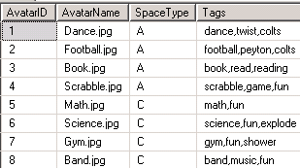

Corresponding files in the file system on the Utility Server









Samples of what is in the files

